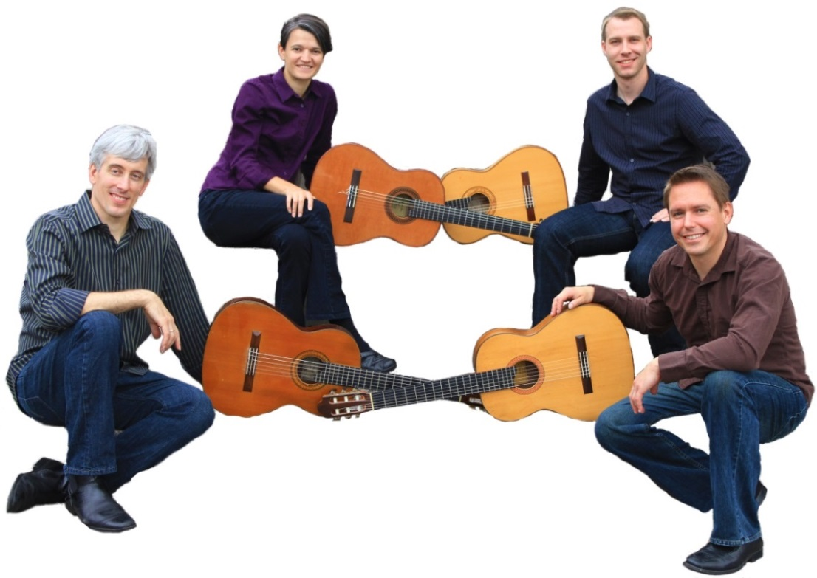
SATURDAY APRIL 25 8:00 PM
MINNEAPOLIS GUITAR QUARTET

A strong and adventurous ensemble
Featuring works by Bach, Rodrigo, Piazzolla and recent pieces by David Crittenden, Maja Radovanlija and Ben Abrahamson
$20 & $15 TGS members at the door or tickets@triangleguitar.org
Carrboro Century Center
100 North Greensboro St
Carrboro NC
www.triangleguitar.org
SATURDAY APRIL 25 8:00 PM

